Market Monitor - Democratic Republic of the Congo - 2026-05

Highlights
In May 2026, the cost of the food basket in DRC decreased, driven by falling prices for most staples. However, a hyperinflationary monthly surge in the price of raw maize and a sharp increase in palm oil signal significant underlying market volatility.
The cost of the food basket decreased by 8.8% month-on-month and 17.1% year-on-year.
Key commodity price changes include:
- Maize: ↑69.0% MoM
- Oil (palm): ↑21.1% MoM
- Wheat flour: ↓18.7% MoM
Key Drivers:
- The overall decrease in the food basket was driven by significant price drops in key staples, notably wheat flour (↓18.7%), beans (↓16.5%), and imported rice (↓7.3%).
- A hyperinflationary monthly surge in the price of maize grain (↑69.0%) created extreme upward price pressure, indicating a strong risk of future price hikes for maize flour, a key staple.
- The price of palm oil rose sharply by 21.1% MoM, partially offsetting the deflationary trend seen in other food items.
- The Congolese Franc remained stable, appreciating slightly against the USD (-0.9% MoM), which helped lower the cost of imported commodities like wheat flour and rice.
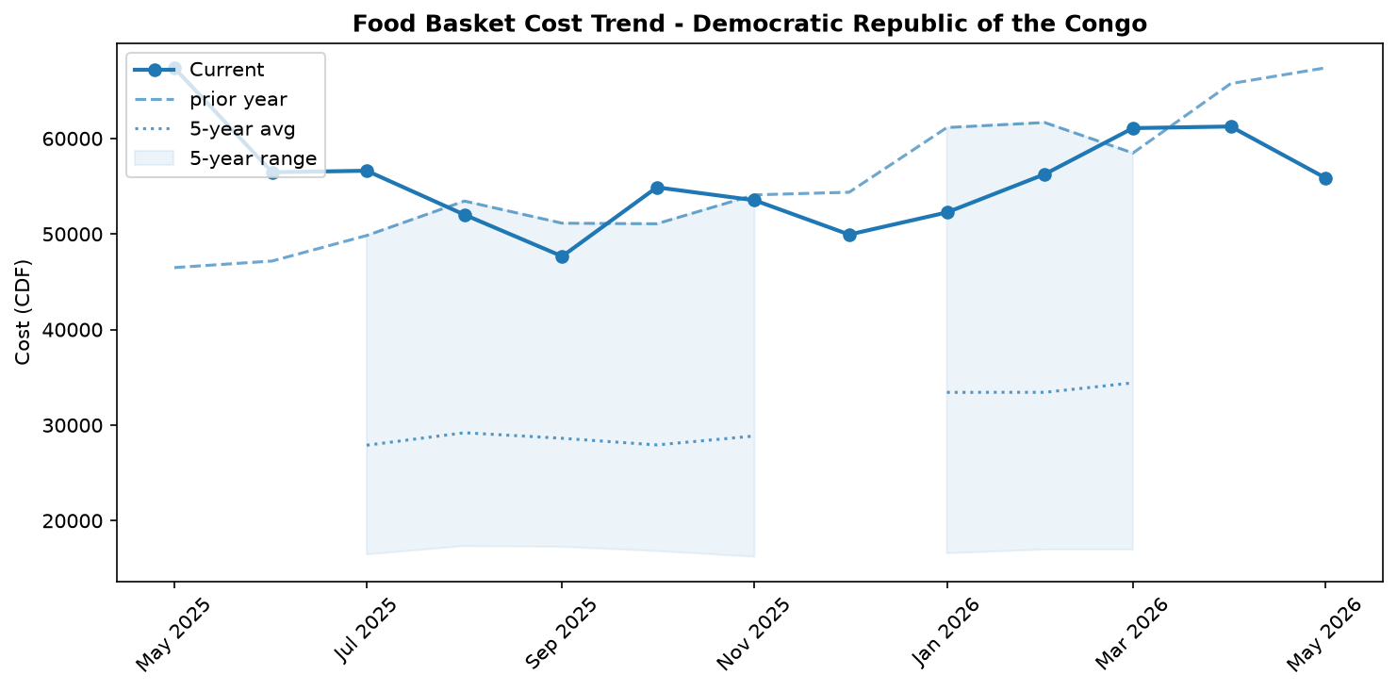
Food basket cost trend

Market Overview
In May 2026, the Democratic Republic of the Congo's markets presented a deceptive picture of stability, with the overall cost of the food basket declining by 8.8 percent month-on-month. This decrease was primarily driven by significant price drops for key staples, including beans (-16.5 percent), wheat flour (-18.7 percent), and imported rice (-7.3 percent). A slight monthly appreciation of the Congolese Franc also provided some relief on the cost of imported goods. However, this apparent deflation masks severe underlying inflationary pressures that threaten to reverse these gains. A massive 69.0 percent monthly surge in the price of raw maize grain signals a critical supply shock that has yet to fully impact retail flour prices. This, combined with a sharp 21.1 percent increase in palm oil and steadily rising fuel costs—with diesel and petrol up 8.7 and 9.6 percent, respectively—creates a high-risk environment. These rising energy and transport costs, coupled with extreme regional price disparities, indicate that the current downward trend in food prices is fragile and likely to be short-lived. The market remains vulnerable to significant volatility driven by logistical bottlenecks and supply chain disruptions.

Commodity Analysis
The commodity market in May was characterized by contradictory price movements, highlighting significant volatility. The most alarming signal came from the maize market, where the price of raw grain surged by a staggering 69.0 percent. This massive increase, likely due to a recent supply shock, stands in stark contrast to the 3.1 percent decrease in the price of processed maize flour, indicating a lag that portends sharp future inflation for this core staple.
This inflationary pressure was partially offset by broad price decreases across other essential foods. Beans, a key source of protein, became significantly more affordable with a 16.5 percent price drop. Similarly, the cost of imported staples fell, with rice and wheat flour decreasing by 7.3 percent and 18.7 percent, respectively. However, these gains were counteracted by a sharp 21.1 percent monthly price hike for palm oil, a critical cooking ingredient.
Meanwhile, non-food commodities are driving up costs. The prices of diesel and petrol continued their upward trend, rising by 8.7 percent and 9.6 percent, respectively. This sustained fuel price inflation increases transport expenses, threatening to raise the consumer price of all goods. In contrast, the meat market was deflationary, with pork prices falling by 7.0 percent and beef remaining stable (+0.8 percent), improving household access to animal proteins.
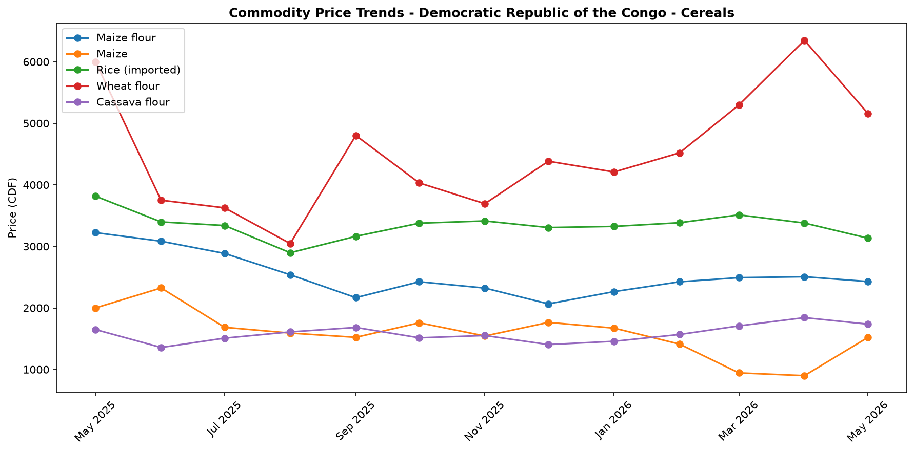
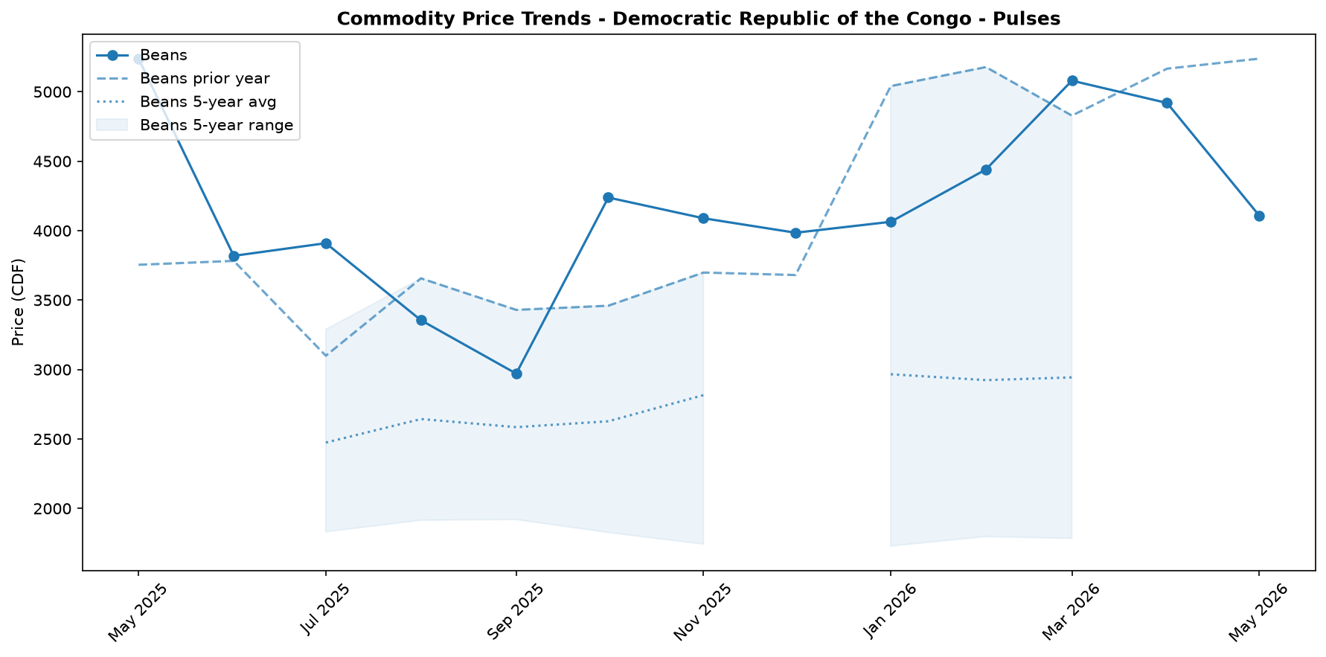
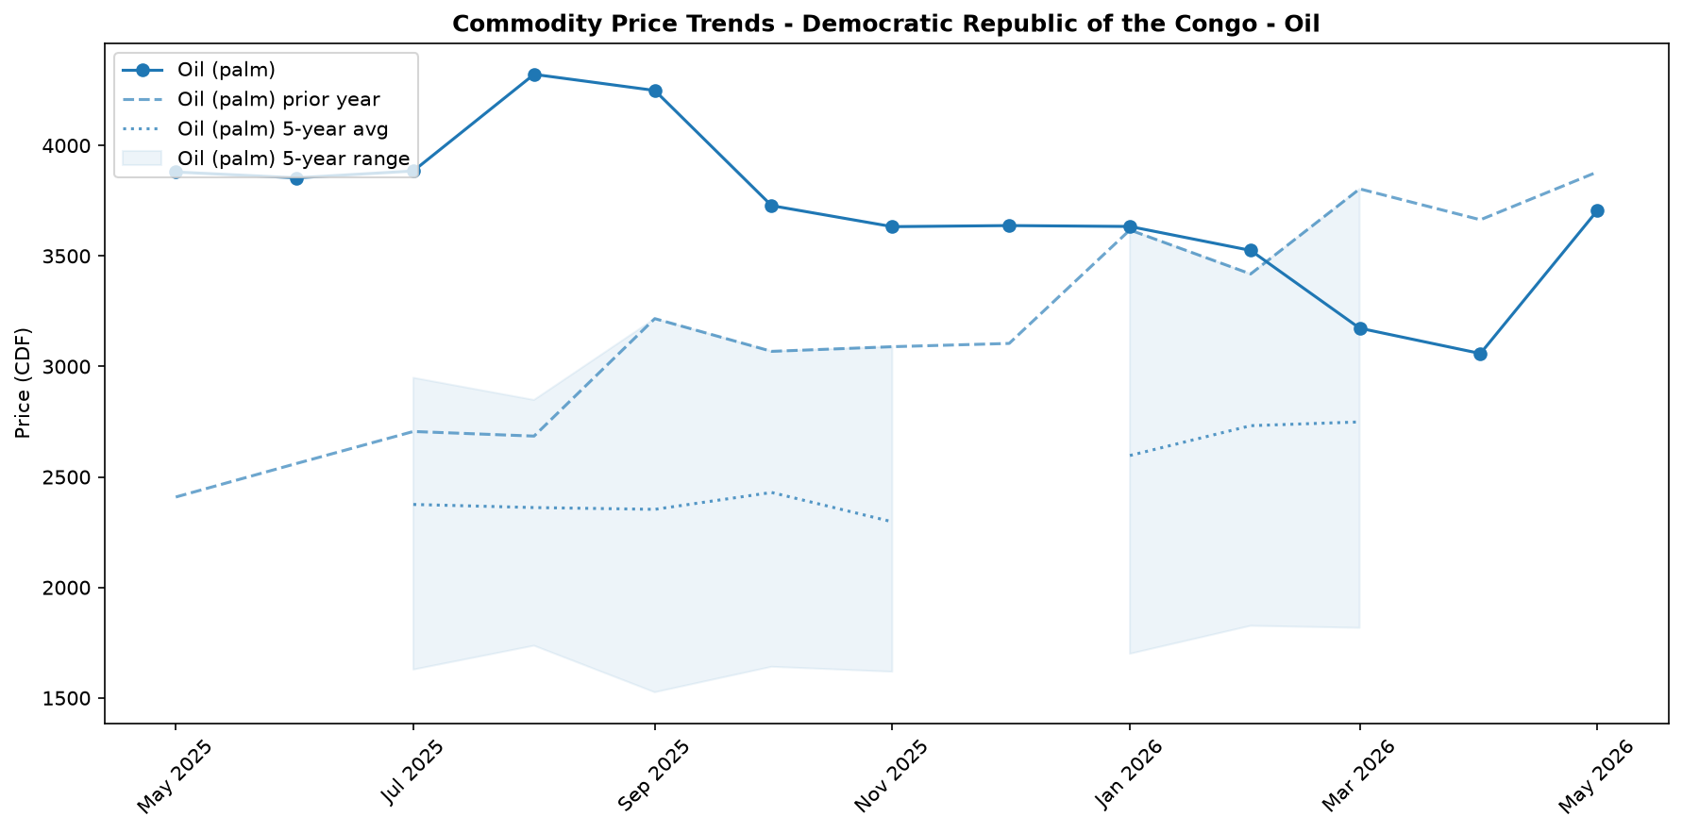
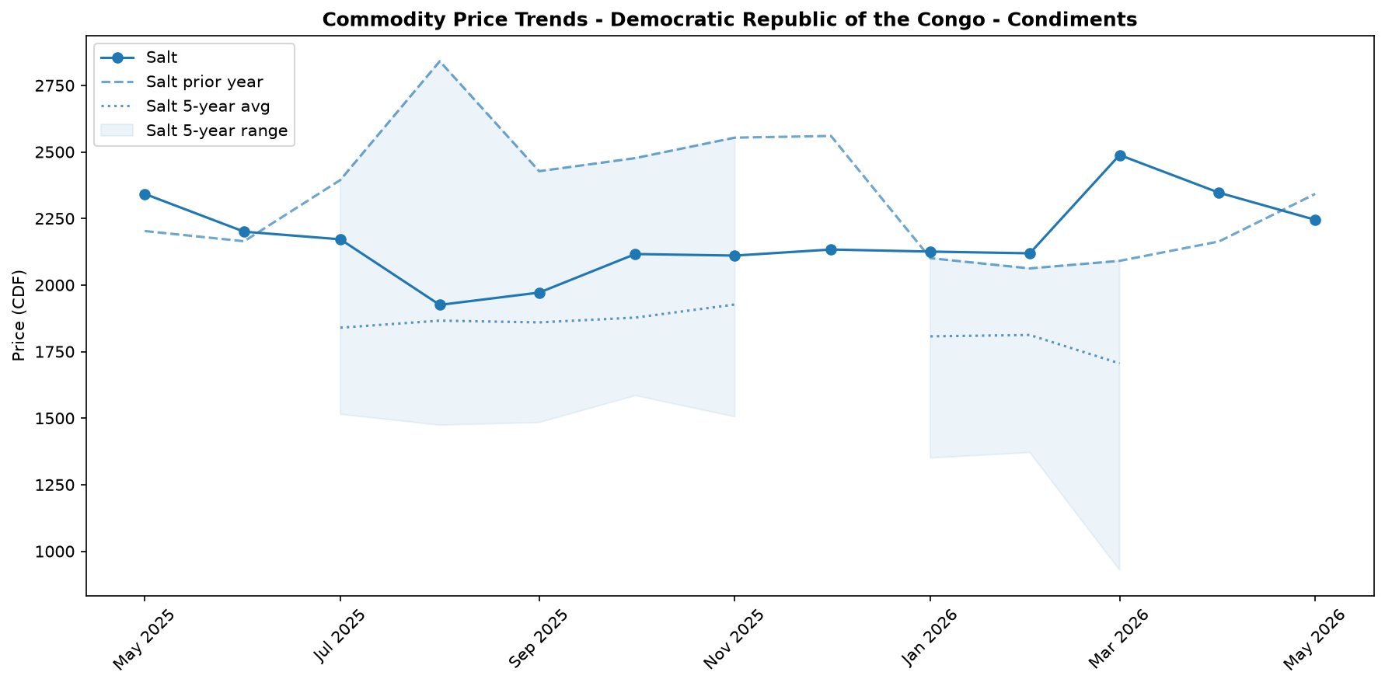

Regional Highlights
Severe market fragmentation remains a defining feature of the DRC's economy, with extreme price disparities between regions highlighting profound logistical challenges. These bottlenecks are exacerbated by insecurity and health-related travel restrictions, such as those advised following the Bundibugyo virus disease (BVD) outbreak. The fuel market starkly illustrates this divide: diesel and petrol in the landlocked Bas-Uele province cost 249.3 percent and 218.4 percent more, respectively, than in the coastal Kongo-Central province. This disparity places an immense burden on transportation, commerce, and the cost of living in remote areas. The market for animal protein shows even more dramatic fragmentation.
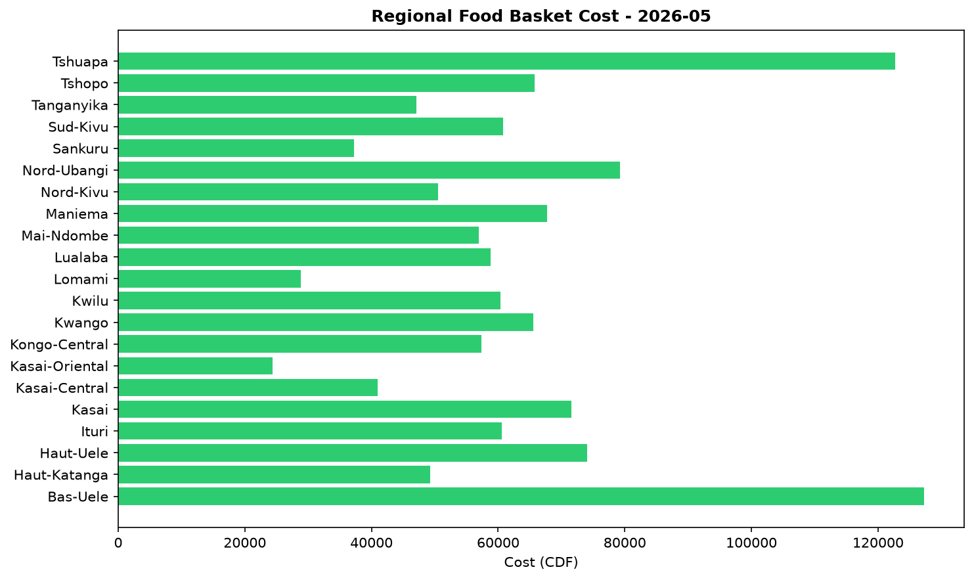
For instance, the price of pork in Haut-Uele is 420 percent higher than in Mai-Ndombe, pointing to highly localized supply chains that are easily disrupted. These vast price differences underscore the lack of an integrated national market and perpetuate cycles of regional economic disparity and vulnerability.

Exchange Rate Analysis
The Congolese Franc (CDF) has recently shown signs of appreciation, trading at an average of 2307.0 per USD. This represents a slight month-on-month strengthening of 0.94 percent, which could help ease the cost of imported goods. However, this short-term gain is set against a significant long-term depreciation. On a year-on-year basis, the CDF has weakened by 20.57 percent, highlighting sustained pressure on the currency over the past twelve months. This substantial annual depreciation continues to exert upward pressure on the prices of key imported commodities, including wheat, rice, cooking oil, and fuel. While the recent monthly appreciation offers a slight reprieve, the overall weaker currency remains a primary driver of food price inflation, eroding the purchasing power of vulnerable households who rely on these imported staples.

Fuel & Energy
The national average price of diesel rose by 8.7 percent month-on-month to CDF 4,729 per litre in May, while petrol increased by 9.6 percent to CDF 4,724 per litre; prices are now 11.0 and 10.1 percent higher, respectively, than one year ago. This increase is consistent with persistent supply and logistics constraints impacting the domestic market. Higher transport fuel costs exert upward pressure on food prices by increasing distribution expenses, which will likely erode recent gains in household purchasing power from falling staple food prices, with significant regional disparities reflected in diesel costing nearly 250 percent more in Bas-Uele than in Kongo-Central.
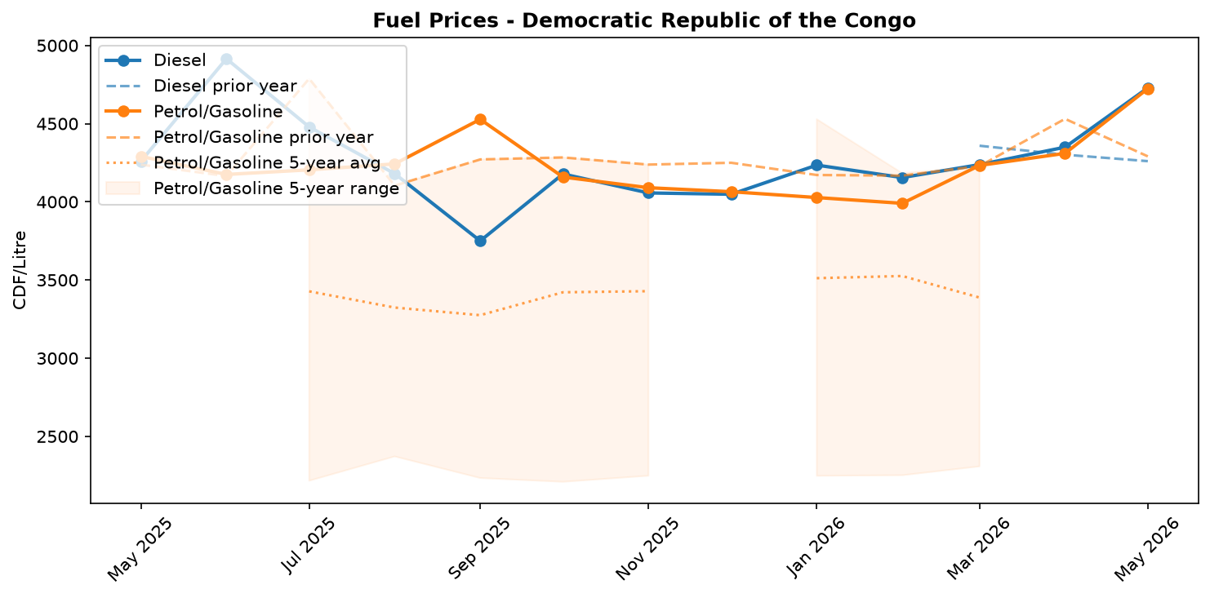
Fuel retail price trend

Livestock & Animal Products
In May, the national average price of beef was largely stable at CDF 18,222 per kg (+0.8 percent) while pork prices decreased by 7.0 percent to CDF 15,758 per kg. This price behavior is consistent with broadly stable supply conditions for animal products, occurring within a wider context of falling prices for other key food staples. The lower year-on-year prices for both meats likely improved household access to animal-source proteins, although significant market fragmentation persists, with pork prices varying by as much as 420 percent between regions.
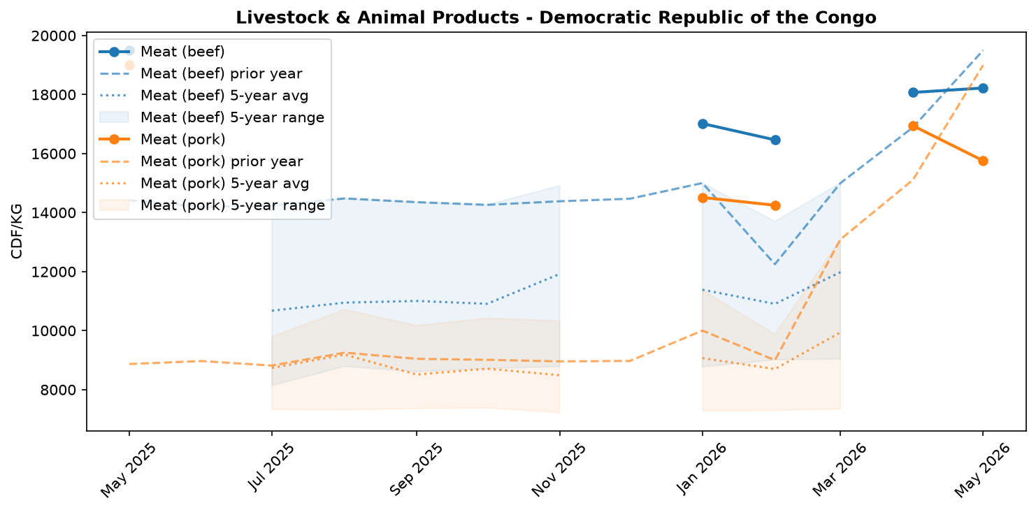
Livestock and animal product price trend

References
- [rw_4214178] ReliefWeb (2026-05-31) IOM: Multi-Country Ebola Bundibugyo Outbreak Situation Report No. 2 (22 - 27 May 2026)
https://reliefweb.int/node/4214178
- [rw_4214159] ReliefWeb (2026-05-30) The metric of life and death: How local and technical experts are strengthening mortality measurement in Eastern DRC
https://reliefweb.int/node/4214159
- [rw_4214140] ReliefWeb (2026-05-29) Disease Outbreak News: Ebola disease caused by Bundibugyo virus - Democratic Republic of the Congo & Uganda (29 May 2026)
https://reliefweb.int/node/4214140
- [rw_4214053] ReliefWeb (2026-05-29) Democratic Republic of the Congo - Ituri Province: Solutions and Mobility Index | Cross-Border Stability Assessment (April 2026)
https://reliefweb.int/node/4214053
- [rw_4214043] ReliefWeb (2026-05-29) UNFPA Flash Update - Bundibugyo Ebola Virus Disease (BVD) Outbreak (20 - 26 May 2026)
https://reliefweb.int/node/4214043
- [rw_4214032] ReliefWeb (2026-05-29) Response to Ebola Outbreak in Democratic Republic of Congo (DRC) and Uganda
https://reliefweb.int/node/4214032
- [rw_4214019] ReliefWeb (2026-05-28) DRC Logistics and Telecommunications Cluster - Standard Operating Procedures (SOPs) for Common Logistics Services, May 2026
https://reliefweb.int/node/4214019
- [rw_4214005] ReliefWeb (2026-05-28) UNICEF’s first international shipment of emergency Ebola response supplies arrives in Ituri, northeastern Democratic Republic of the Congo
https://reliefweb.int/node/4214005
- [rw_4213975] ReliefWeb (2026-05-28) Message by the WHO Director-General to the people of the Democratic Republic of the Congo
https://reliefweb.int/node/4213975
- [rw_4213814] ReliefWeb (2026-05-27) DRC: One in four confirmed Ebola deaths are children underscoring the urgent need to protect them
https://reliefweb.int/node/4213814
- [seerist_1028756] Seerist (2026-05-28) Big Picture series: Ebola outbreak prompts increased travel monitoring, targeted entry restrictions
- [seerist_1028721] Seerist (2026-05-27) Big Picture series: Carbon markets in Sub-Saharan Africa – growing opportunities amid regulatory, integrity challenges
- [seerist_1028614] Seerist (2026-05-20) US-Congo strategic partnership to advance peace deal enforcement, but challenges to critical minerals output will remain
- [seerist_1028608] Seerist (2026-05-19) Ebola outbreak highlights response weaknesses amid fragmented administrative control, funding decline
- [seerist_1028607] Seerist (2026-05-19) Big Picture series: France’s push into anglophone Africa to bring new commercial opportunities despite West African controversies
- [seerist_1028505] Seerist (2026-05-12) Insecurity in mining provinces to persist in coming years despite planned deployment of paramilitary force
- [seerist_1028483] Seerist (2026-05-11) President signalling two ways to stay in office beyond 2028 suggests renewed push to extend tenure
- [seerist_1028458] Seerist (2026-05-08) US sanctions on former president to strengthen ruling camp, raise compliance risks
- [seerist_1028377] Seerist (2026-04-30) Risk zones, risk ratings changed to reflect impact of rebel offensive
- [seerist_1028293] Seerist (2026-04-24) Fighting in eastern Congo to continue in coming months as implementation of peace process remains uneven

